Task related to ECS.
- Setup a highly available ecs cluster with load balancer and dynamic port mapping.
NOTE:
Your cluster should maintain atleast 6 tasks at any point of time and should be highly availble across multiple AZ's.
Use the below image from deployment:
sabair0509/hiring-app:works
- Create ECS Cluster
Go to ECS → Clusters → Create Cluster
Name: hiring-app-cluster-2
• Choose: Fargate and self-managed instances
• Autoscaling group (ASG): Create a new ASG
• Provisioning Model: on-demand
• Select container instance AMI : Amazon Linux 2023
• EC2 instance type : t3.micro (free-tier)
• Select EC2 instance role : Default
• Desired Capacity: Minimum-2 & Maximum-6
• SSH KeyPair : available keypair
• Root EBS Volume size : 30
• Create
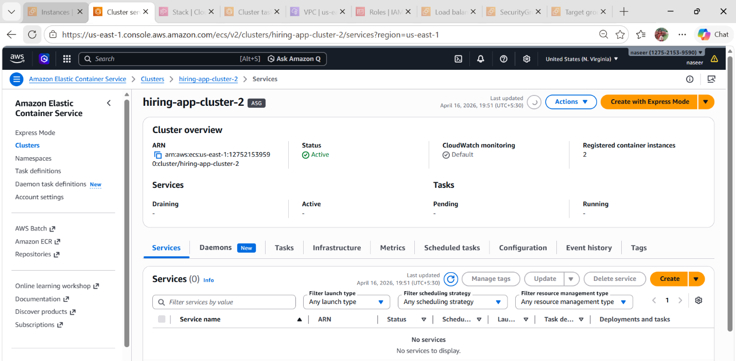

- Create Task Definition
• Go to Task Definitions → Create
• Name: Hiring-app-task
• Launch type: AWS Fargate
Configure:
Task size: CPU: 0.5 vCPU and Memory: 1 GB
• Task execution role: default
Container:
• Name: Hiring-App-Cluster
• Image : sabair0509/hiring-app:works
• Port mappings:
o Container port : 8080
o Protocol : TCP
o App Protocol: HTTP

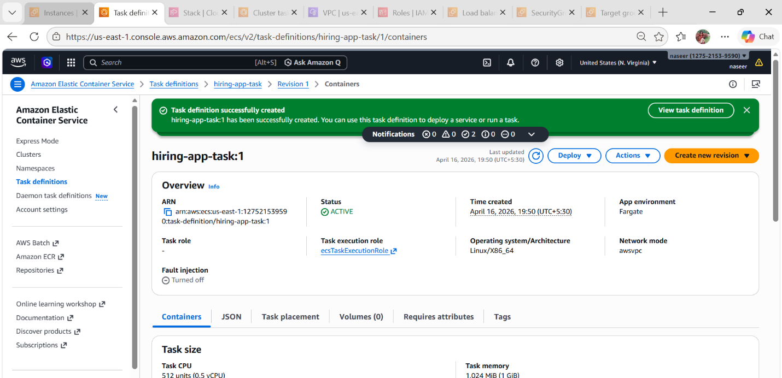
- Create Application Load Balancer (ALB)
• Go to EC2 → Load Balancers → Create
• Choose: Application Load Balancer
Configure:
• Scheme: Internet-facing
- Name: hiring-app-applb
• Load balancer IP address type : IPv4
• Network Mapping: Select VPC : Default VPC
• Subnets: Select at least 2 AZs
• Security Groups: Default
• Listeners: HTTP (port 80)
• Routing action : Forward to target groups
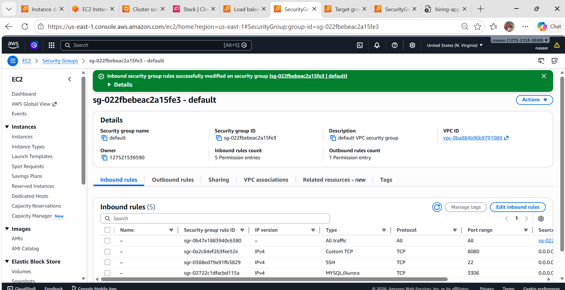
- Create Target Group
• Target Type: IP (IMPORTANT for Fargate)
Name: hiring-app-target
• Protocol: HTTP
• Port: Traffic port (80)
• Health Check Path : /hiring
• Healthy Threshold : 2
• Unhealthy Threshold : 5
• Timeout: 5sec
• Interval : 15sec
• Source codes: 200-399
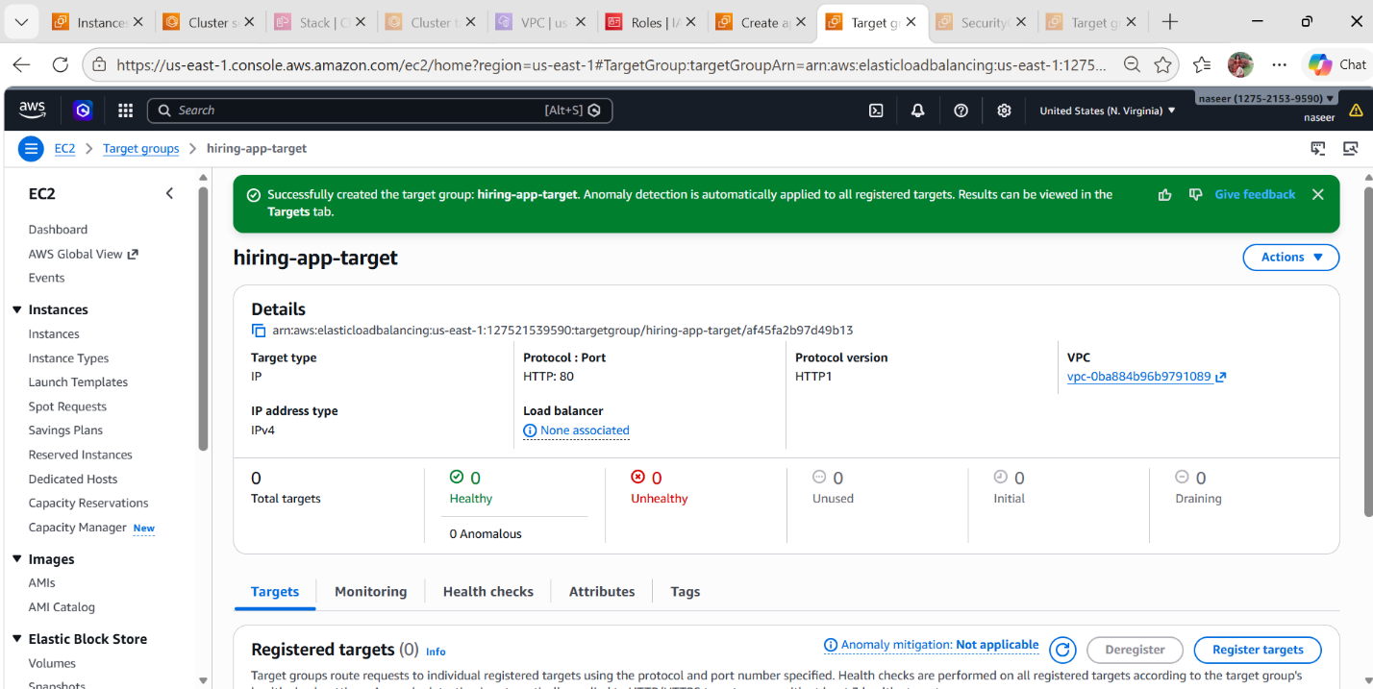

Next go to load balancer and refresh target groups then select created target group and then click on create.
We can see the Created hiring-app-applb

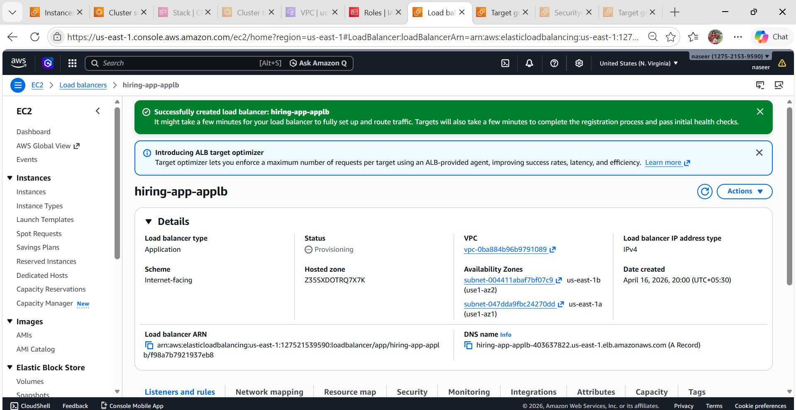

- Create ECS Service
• Go to ECS Cluster → Create Service
Configure:
• Task Definition family : hiring-app-task
• Service Name: Hiring-app-
Deployment Configuration:
• Scheduling Strategy :Rplica
• Desired Tasks: 6
• Turn on Availability zone rebalancing : Enable
• Health check grace period: 30 sec
- Deployment options should be like same as default
Networking select default VPC and select 2 subnets
Load Balancer Setup:
• Enable Load Balancer: ✅
• Type: Application Load Balancer
• Select:
o ALB created earlier
o Listener: HTTP:80
o Target Group: created earlier
• Click on create
We can see that Service has been created successfully

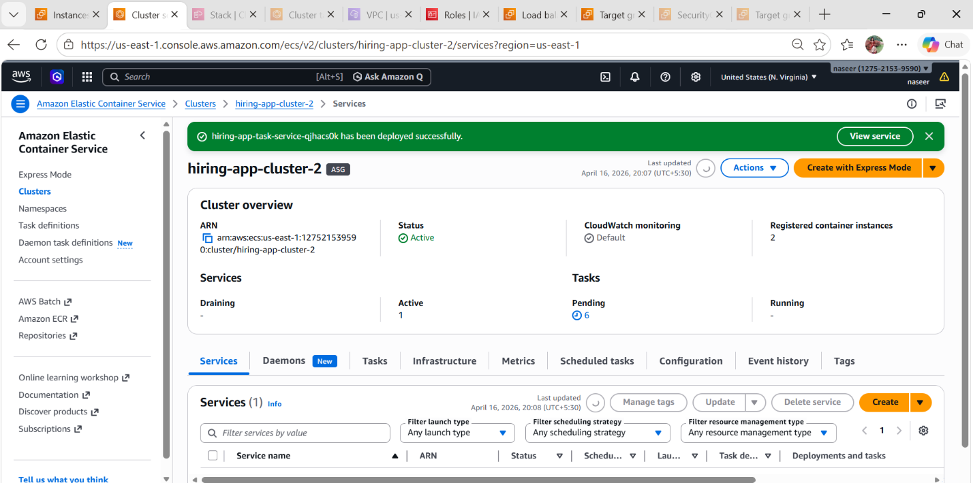

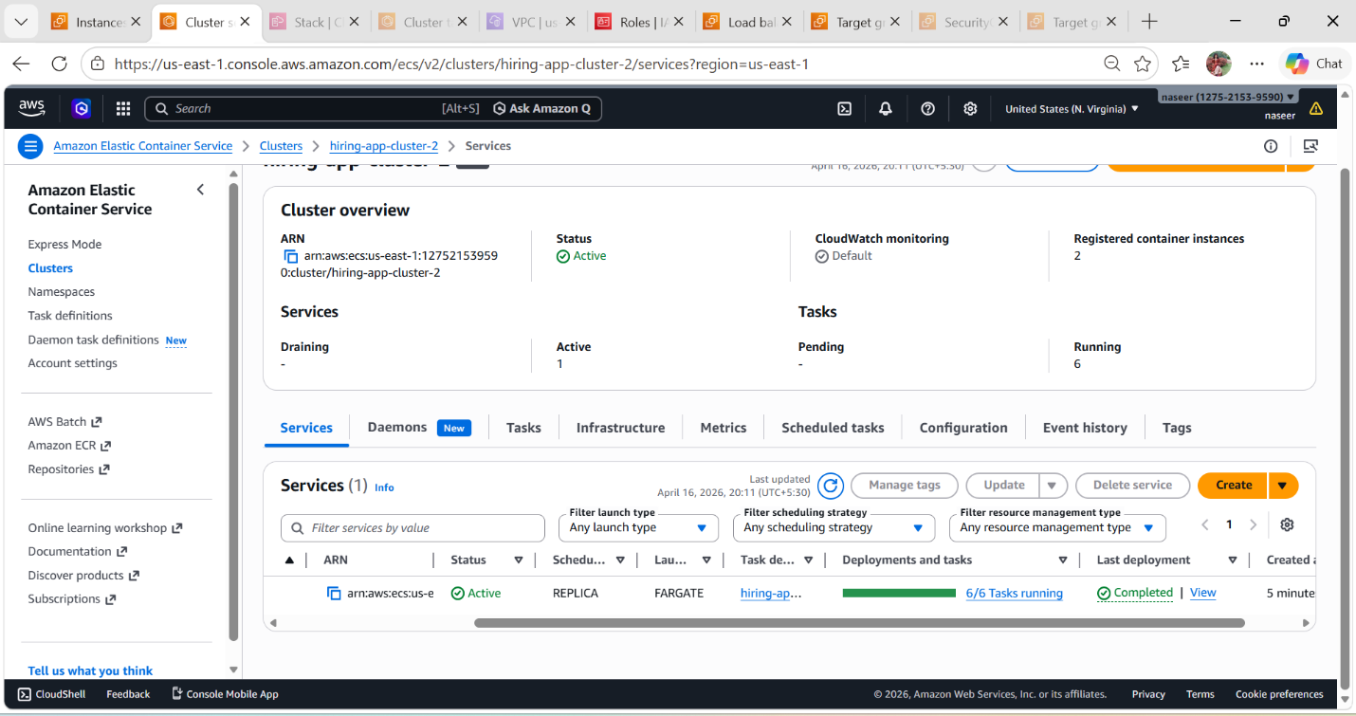
• After the service created then go to tasks we can see that tasks got created and running Verify Deployment
• Go to ECS → Service
• Check: Running tasks = 6
Go to EC2 → Target Group: Targets should be healthy
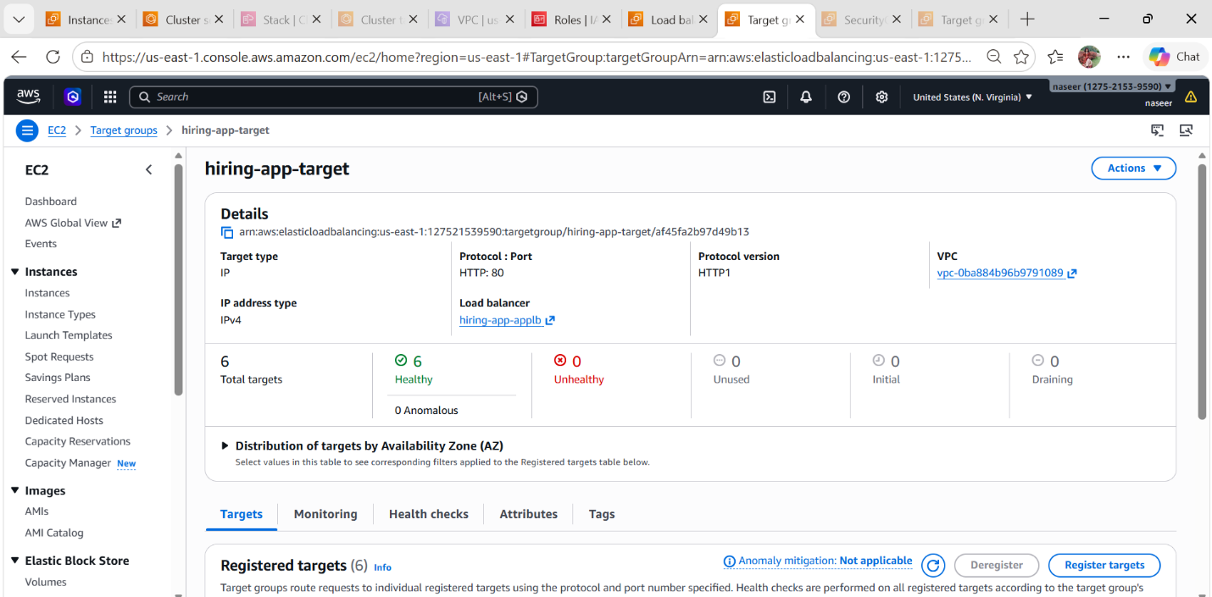
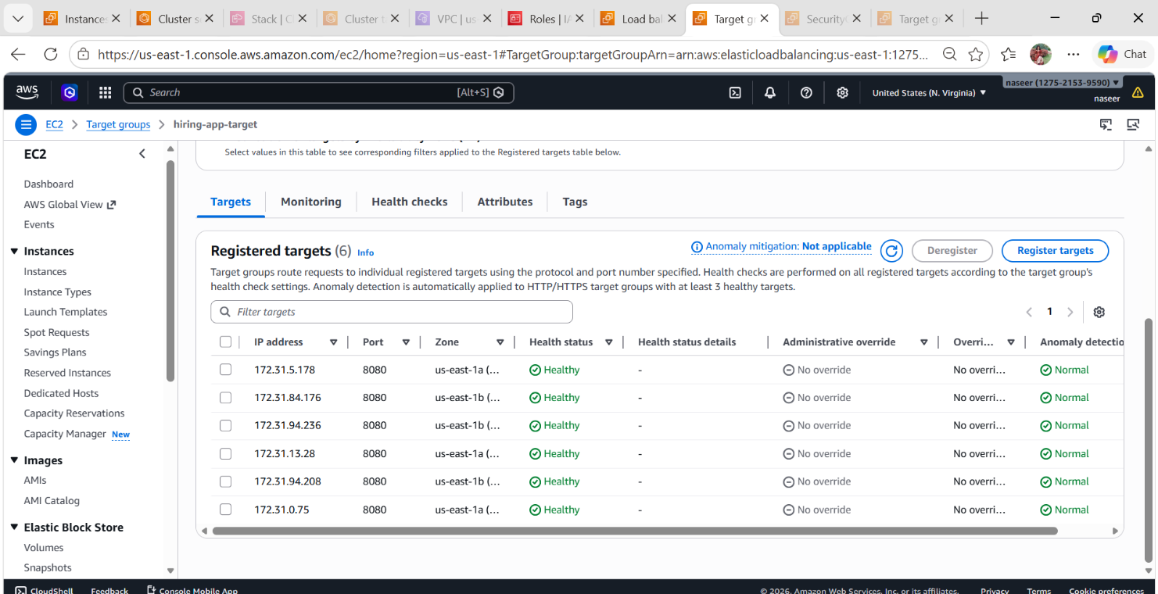

- Goto clusters and inthat click tasks there we see 6 running tasks.

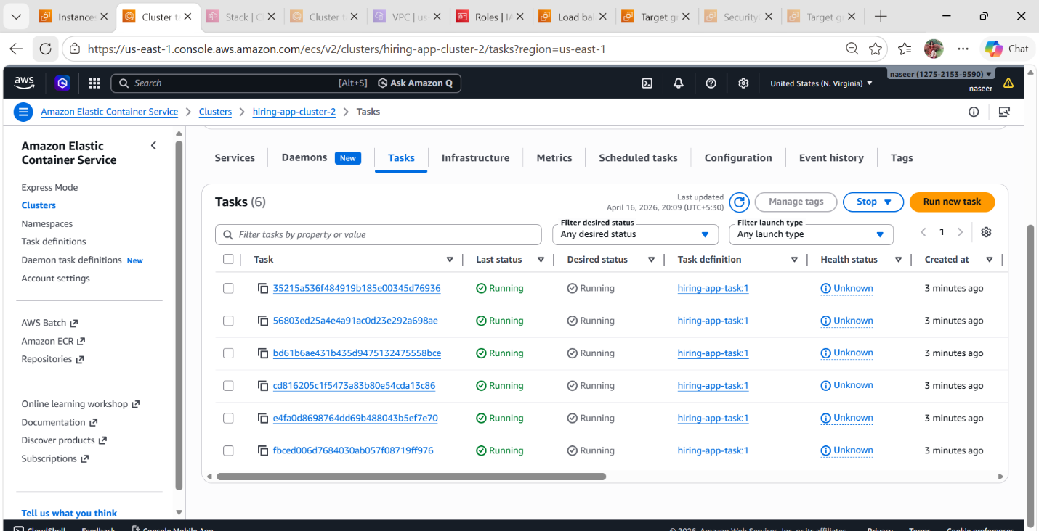

Check App Response :
• Open in browser:
http://hiring-app-applb-403637822.us-east-1.elb.amazonaws.com:80/hiring/
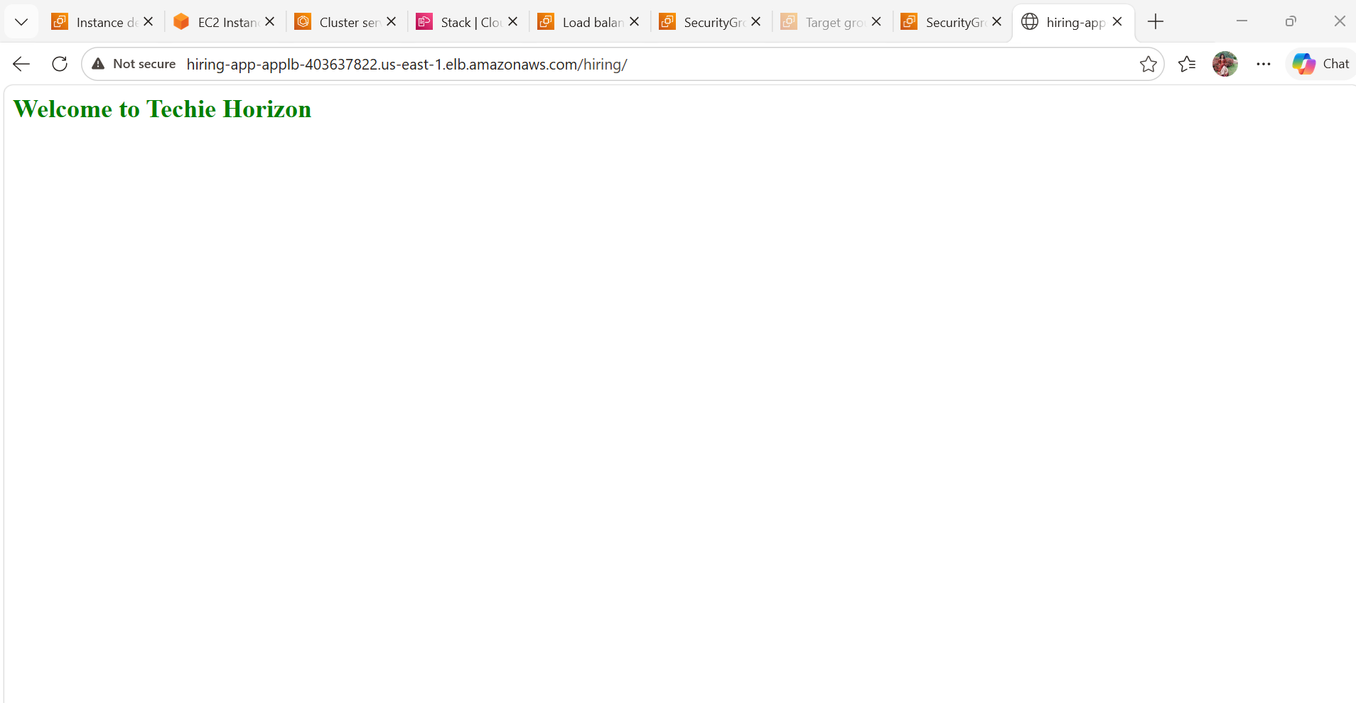
- Goto AWS ec2 and check new instances launched nad running state.
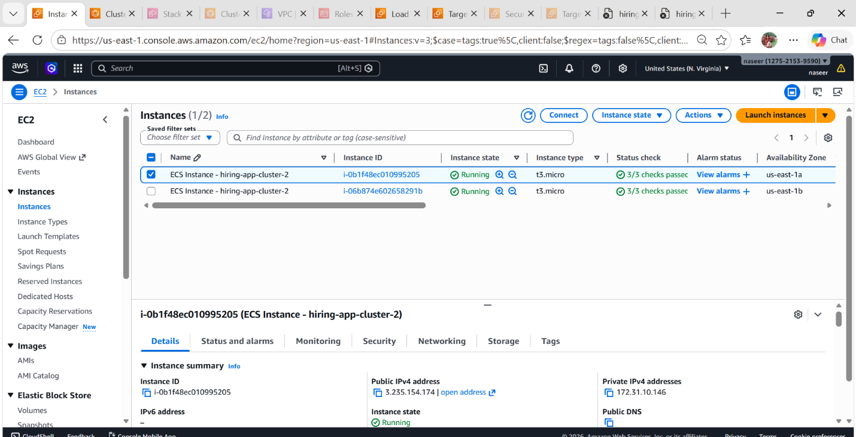

- Goto cloud formation and check stack then 2 new stacks created.
